**ICE 8**

id:7   
name: Harshil Patel

[Document](https://github.com/Harshilpatel134/IOT/tree/master/ICE/module2/ICE1/document)   
[Scource](https://github.com/Harshilpatel134/IOT/tree/master/ICE/module2/ICE1/Scource)

**objective**

in this icp we are setting raspberry pi and connecting raspberry pi with arduino and running the basic task.

1. Setup Raspberry Pi
2. Create circuit board with LED light and Raspberry Pi
3. Connect Raspberry Pi with Arduino and receive message from Arduino
4. Send tweet from Raspberry Pi

**workflow**

**blinking led light using rasberry pi**

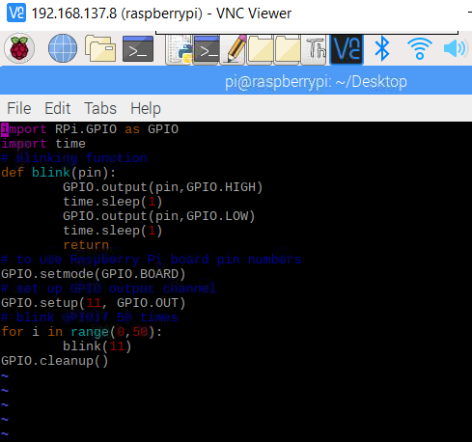

**arduino code to send message to raspberry pi via i2c.**

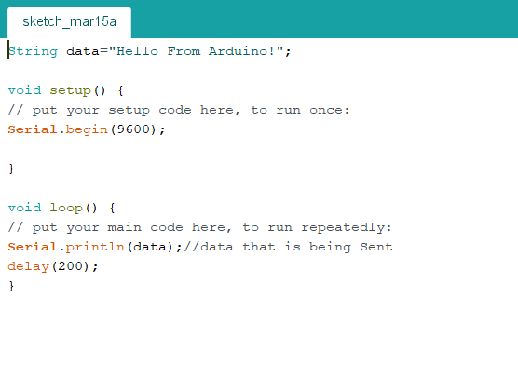

**raspberry pi code to recive message from arduino**

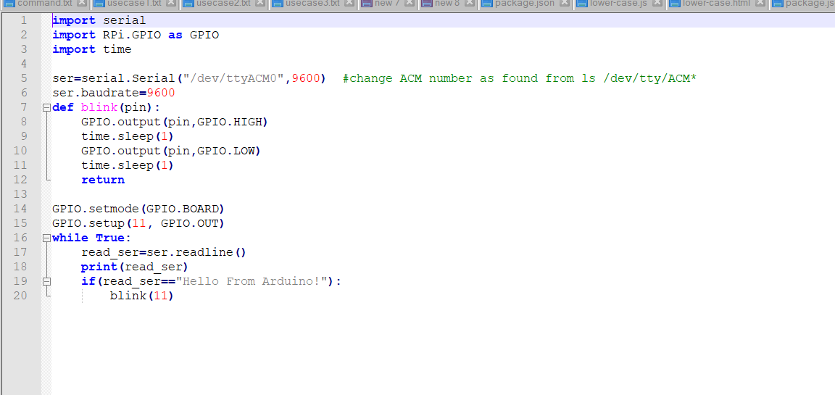

**raspberry pi code to send tweet to twitter.**

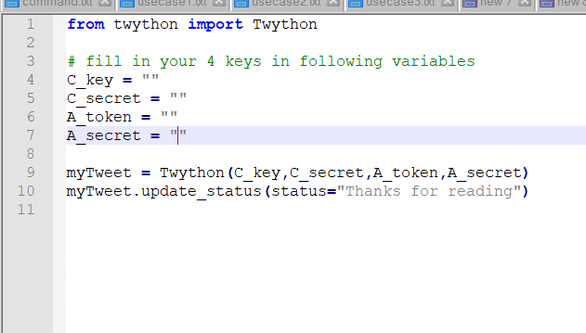

**tweet output**

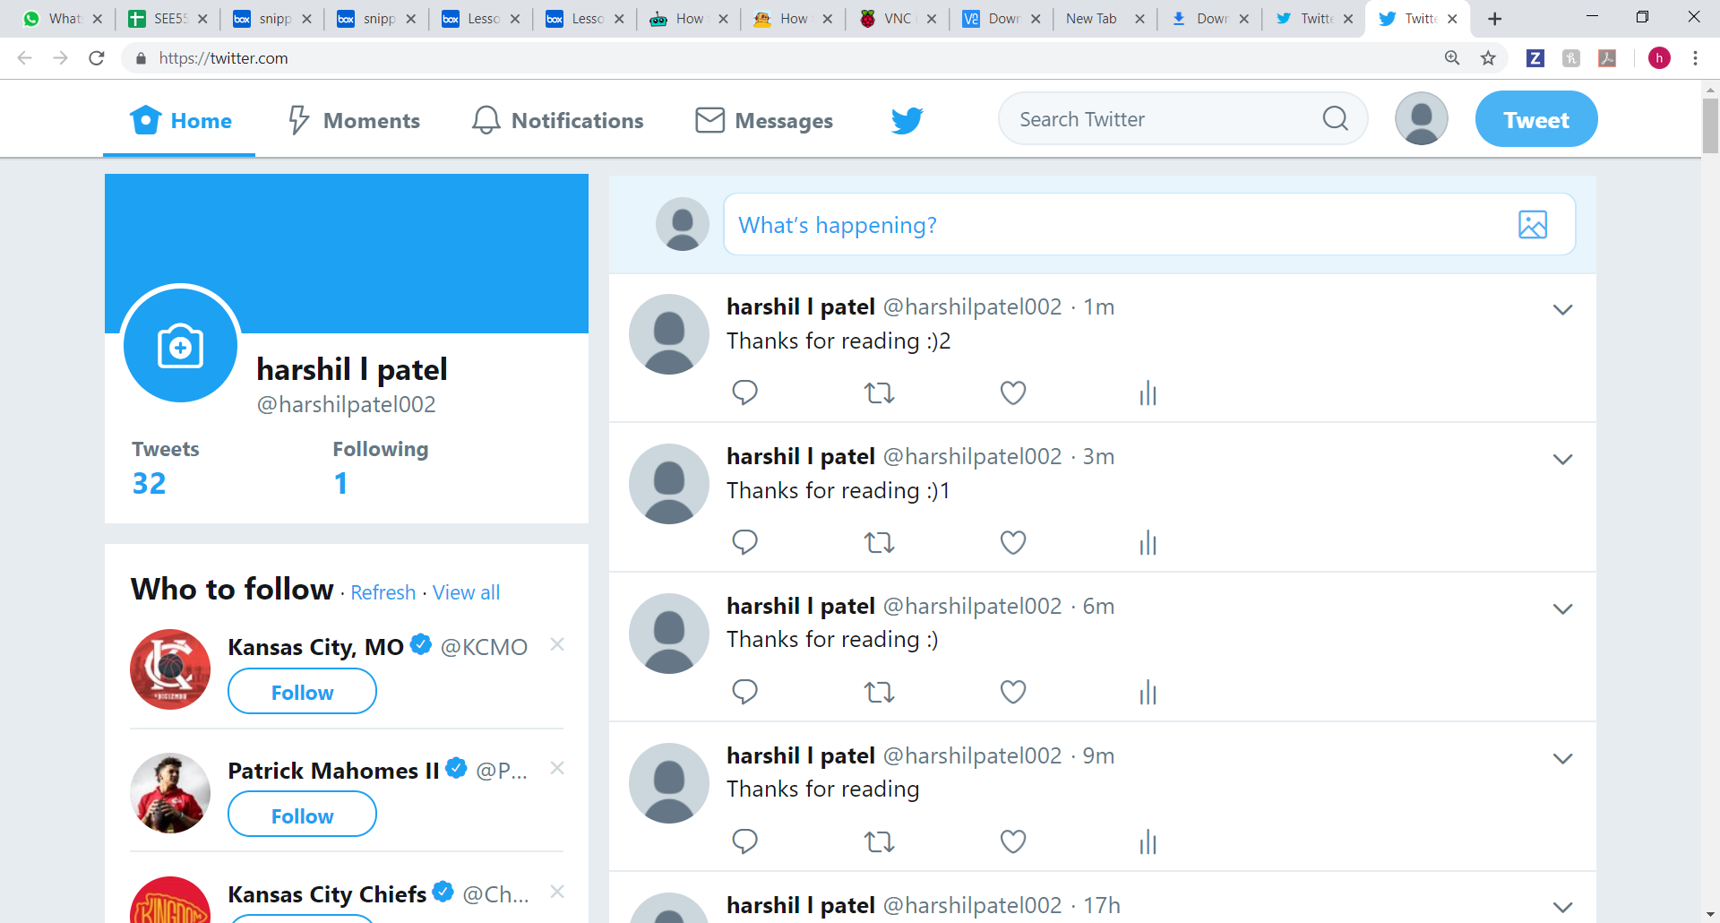

**conclusion**

with the help of this assignment we where able to learn...

1. Setup Raspberry Pi
2. Create circuit board with LED light and Raspberry Pi
3. Connect Raspberry Pi with Arduino and receive message from Arduino
4. Send tweet from Raspberry Pi